- To access your webserver from your browser, use your FQDN in your browser;

[for this example, [yourRCSid]RPI will be replaced with rplotka]

[yourRCSid]RPI.eastus.cloudapp.azure.com

youRCSidRPI.eastus.cloudapp.azure.com
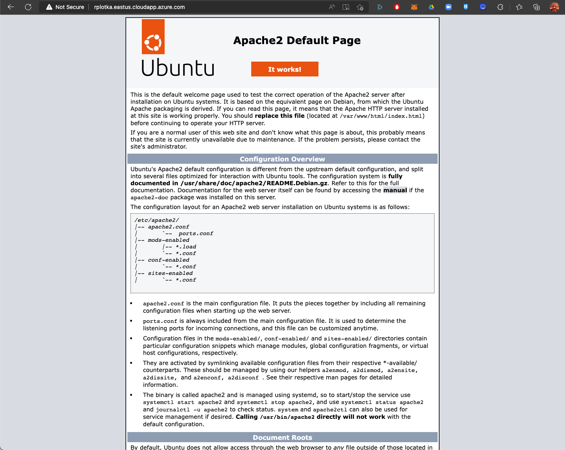

- Check your PHP installation, using out browser, go to

http://[yourRCSid]RPI.eastus.cloudapp.azure.com/checkphp.php

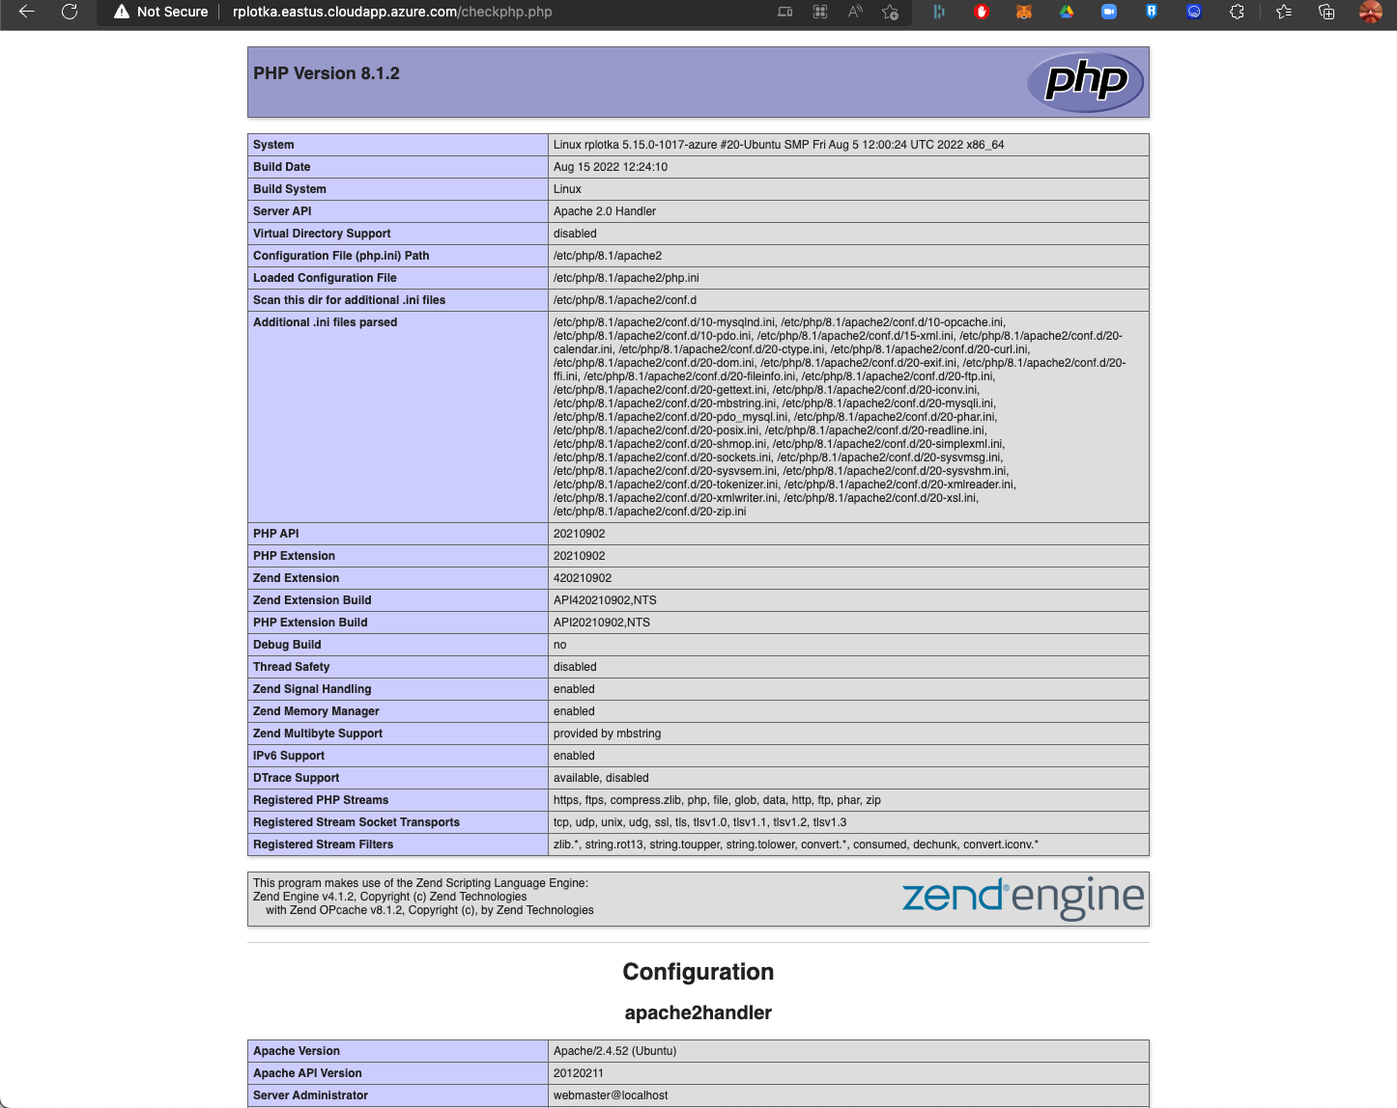

Print out this page to PDF

- To Access your VM from your computer (without the browser);

From your computer
Open Terminal

Type SSH RSCid@[your FQDN]

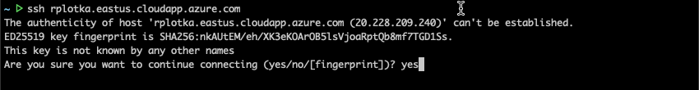

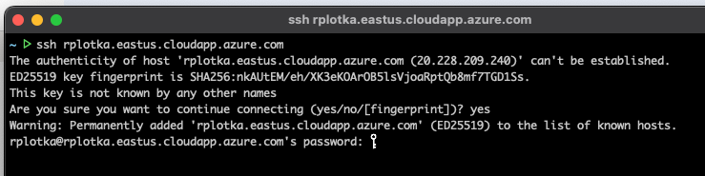

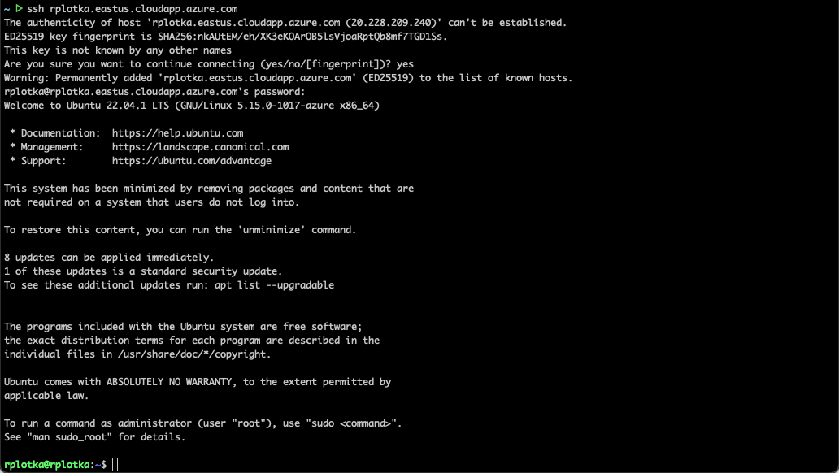
- Now we are logged on to the other computer. We need to create a location to hold our personal website

First, we need to make sure the web server user www-data has the correct authority to the folders, type:

$ sudo chown -R www-data:www-data /var/www/html

Web pages are served from /var/www/html, so let’s go there:

Type:
cd /var/www/html

ls -la

Now we need to create some folders for our website
Create our class root folder;
sudo mkdir iit

sudo chown -R www-data:www-data iit

Create our security key folder (more soon)
sudo mkdir /var/www/.ssh

sudo chown -R www-data:www-data /var/www/.ssh

Note: sudo (Super User Do) is a utility that allows us to run commands on our Linux machine with supervisor authority. Just like running an app with supervisor or administrative authority on our computers.

Now let’s add ourselves into the www-data group

sudo usermod -a -G www-data [yourRCSid]

Log out and then log back in
Make sure you are in the group by typing

groups

You should see www-data in your list of groups

Now let’s move into our iit folder

Type:

cd /var/www/html/iit

Now let’s create a simple webpage

Type:

sudo nano index.html

Type the following in the editor (or cut/paste)

<html>
<head>
</head>
<body>
<p>Hello World!</p>
</body>
</html>

Then type (NOTE: <ctrl> is the control key, and <Enter> is the enter key)
<ctrl>O followed by <Enter>
Which saves our changes. Then type
<ctrl>X
Which exits and brings us back to the command line

This will put you back at the command prompt.

- Type ls

You should see index.html listed

Now let’s test it by going to FQDN/iit in our browser

Eg

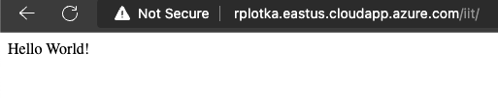

Print out this page
- Now let’s remove public access from our sites

First, we need to allow our server to allow authentication

sudo nano /etc/apache2/apache2.conf

<ctrl-w> and search for ‘/var/www/’
change
AllowOverride None
to
AllowOverride All

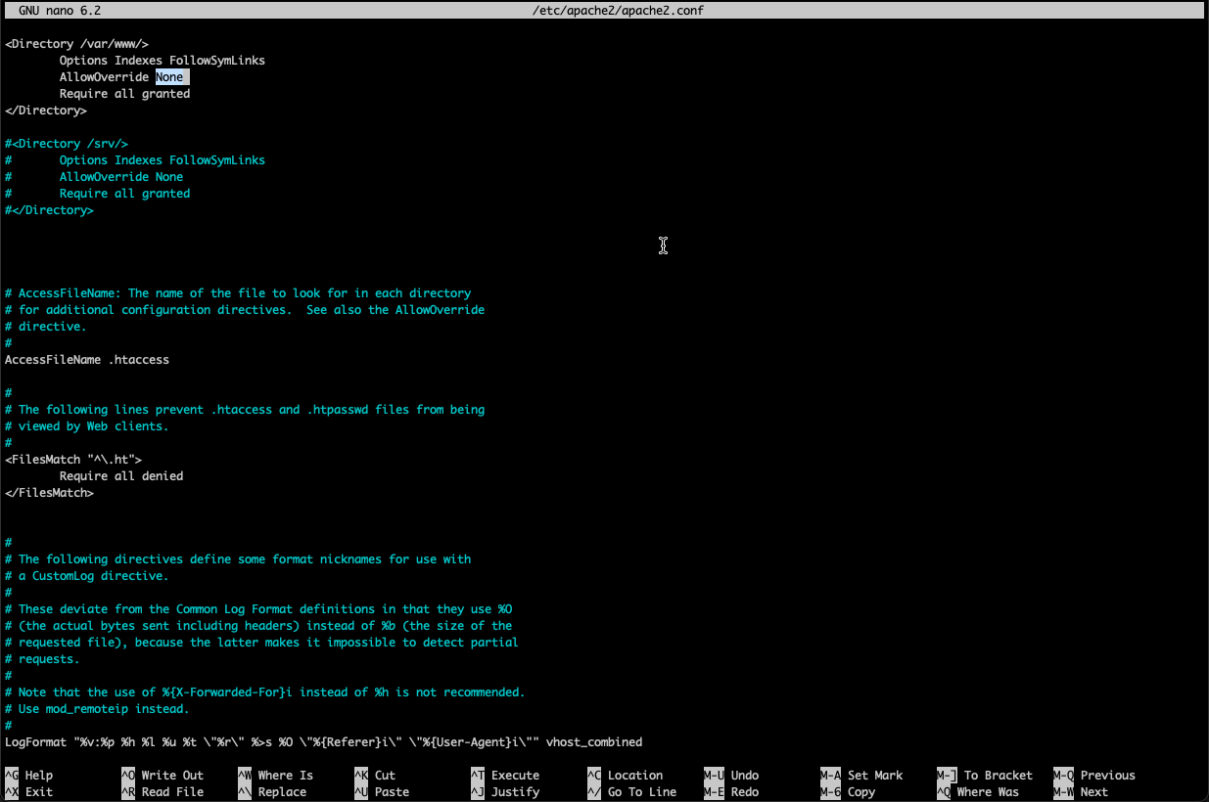

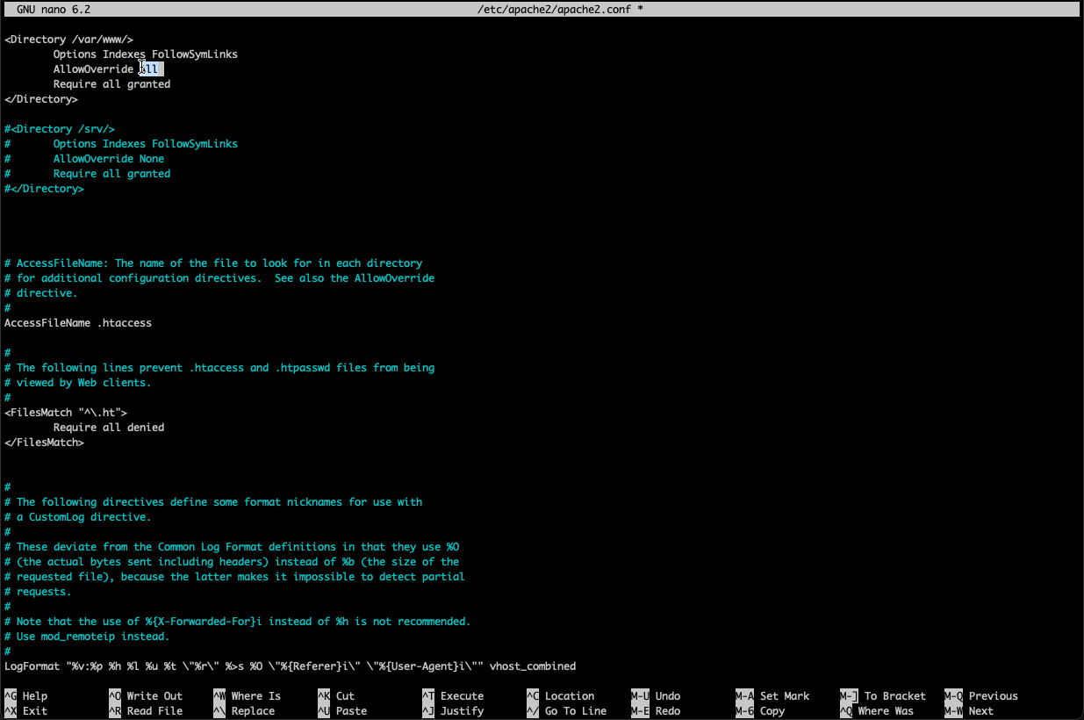

- Now, let’s create a file to allow our iit folder to be seen by authenticated users

sudo nano /var/www/html/iit/.htaccess

cut/paste the following

AuthType Basic
AuthName "Restricted Content"
AuthUserFile /etc/apache2/.htpasswd
Require valid-user

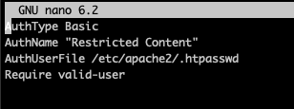

Now let’s add some users and passwords

For the first user – you – we need the -c flag
sudo htpasswd -c /etc/apache2/.htpasswd [yourRCSid]
enter a password

NOTE – omit the -c after the first time you type the command

sudo htpasswd /etc/apache2/.htpasswd rplotka
sudo htpasswd /etc/apache2/.htpasswd [TA RCSid][mojiso]

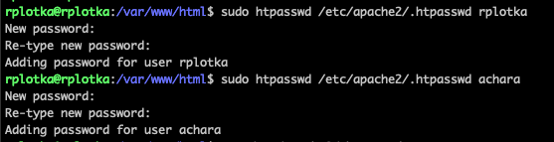

let’s check by typing
cat /etc/apache2/.htpasswd

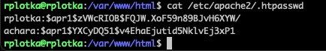

Let’s restart our server to have our changes take effect
sudo service apache2 restart

